**Oracle Homework Chapter 2 (Ch2_Homework)**

**Include the following comments at the top:**

**-- Your Name**

**-- Date**

For each of the queries, type an SQL statement into SQL Developer. Name each query in the format ch2px, where x is the problem number, e.g. ch2p1, ch2p2, etc. Put all queries in one SQL script.

Use a comment to identify each query, as shown (put all in one script):

-- ch2p1

The code for p1

-- ch2p2

The code for p2

Save as Ch2_Homework in your folder c:\oracle\ch2.

Make sure your solutions are easy to read. Put the SELECT and FROM clauses on separate lines. Capitalize all keywords, use lowercase for tables and columns and user-defined identifiers. Also make sure the queries are in order and numbered. If you have them out of order they will be marked wrong. Submit ch2_Homework to the appropriate folder in the D2L Dropbox.

1. Create a query to display unique student classes from the STUDENT table. Label the column “Classification”, as shown below:

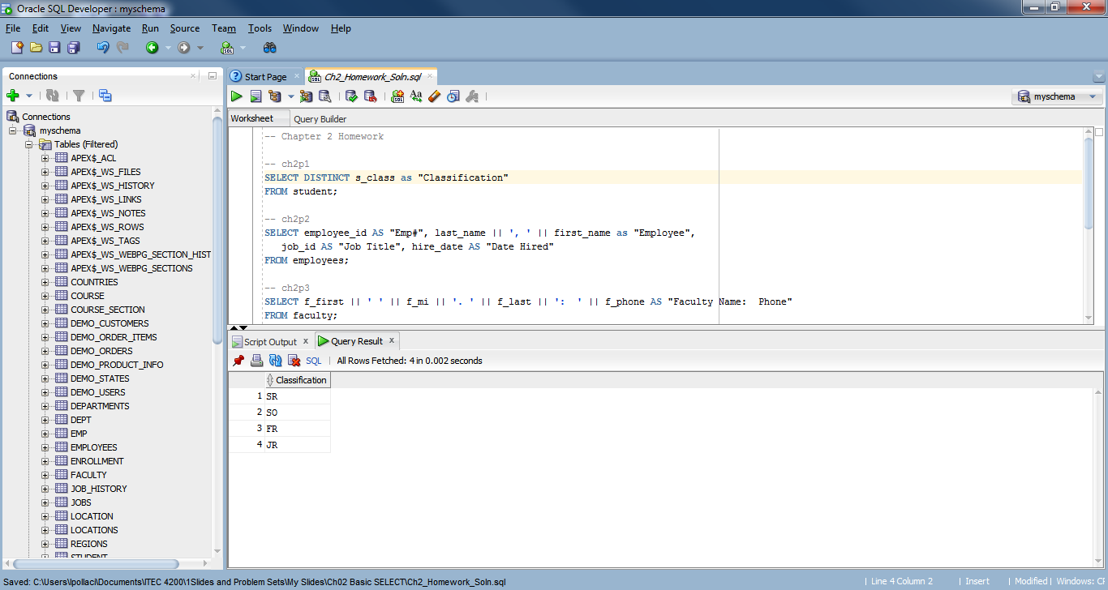

1. Create a query to display the full name (lastname, firstname), job, hiredate and employee number for each employee, with the employee number appearing first. Name the column heads Emp#, Employee, Job Title, and Date Hired, respectively. The first records of the results are shown below (there will be more records in the full output.)

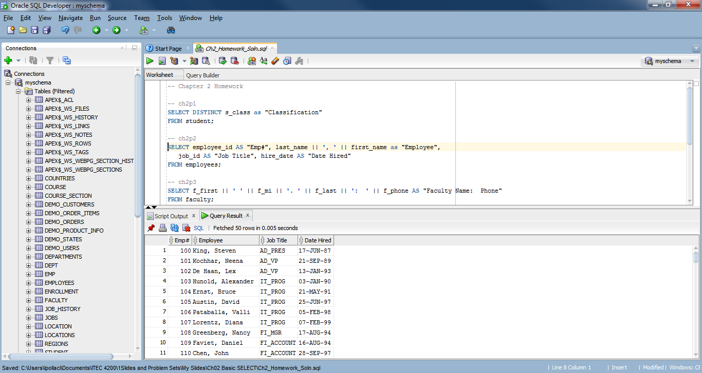

3. Display the full name of the faculty member, along with their phone number, as shown by the output below. There is just one column.   
  
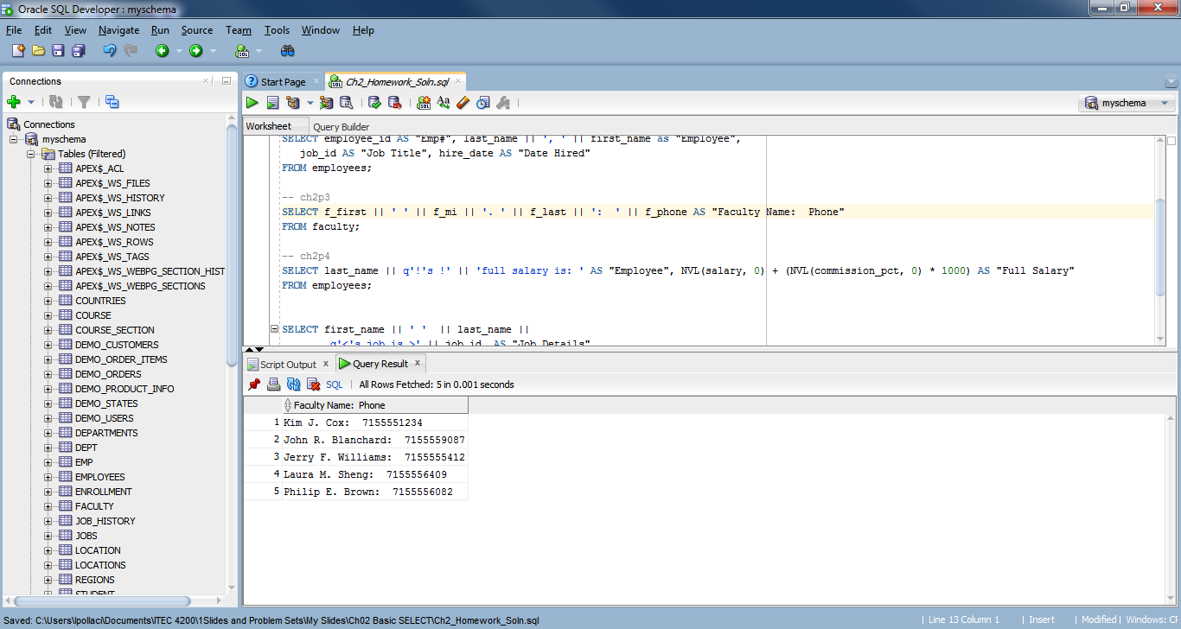

1. Select the employee name and text as shown below, the full salary (salary plus commission percent times 1000. Values should be shown, even if there is a null value. Use the alternative quote delimiter and column headings as shown below:

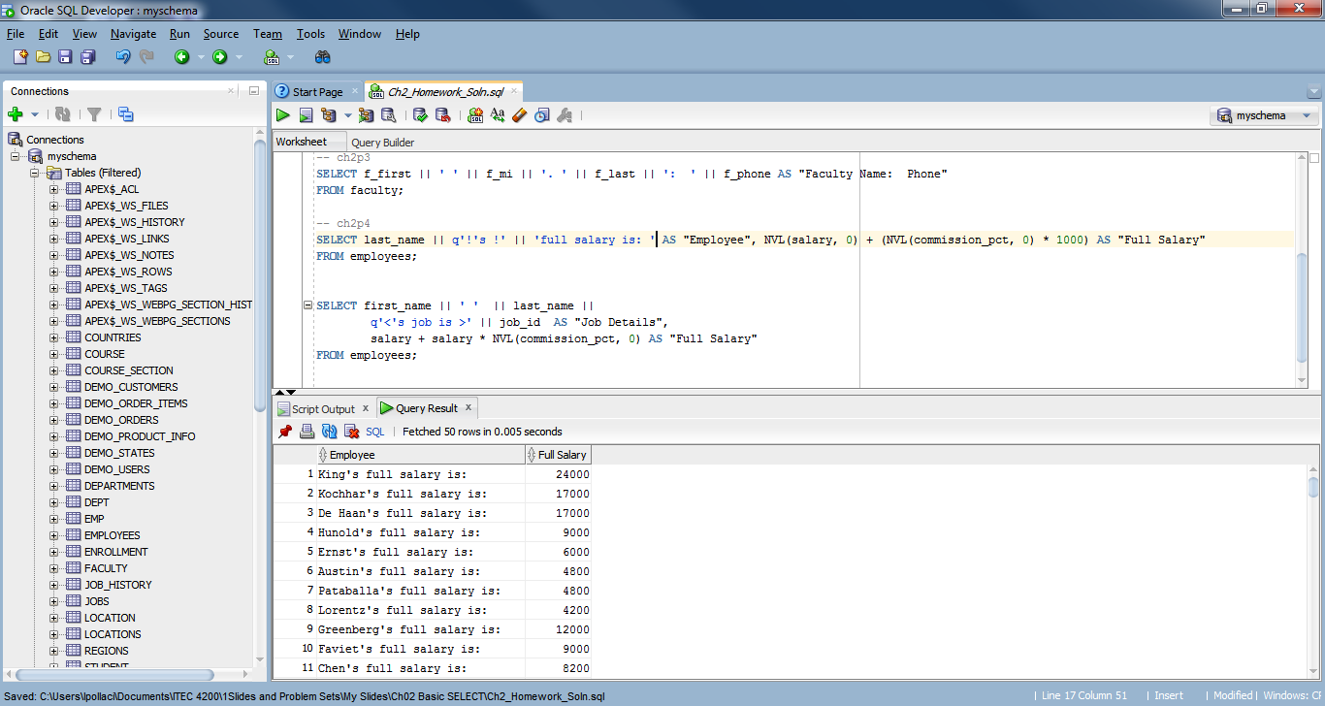

1. This exercise illustrates date arithmetic. You can subtract one date from another to get the number of days in between. Also it asks you to change the default order of the results.

Make a query from the job_history table that lists the employee’s id, their start date, end date, and the number of days of employment. Order the resulting rows by the days of employment.

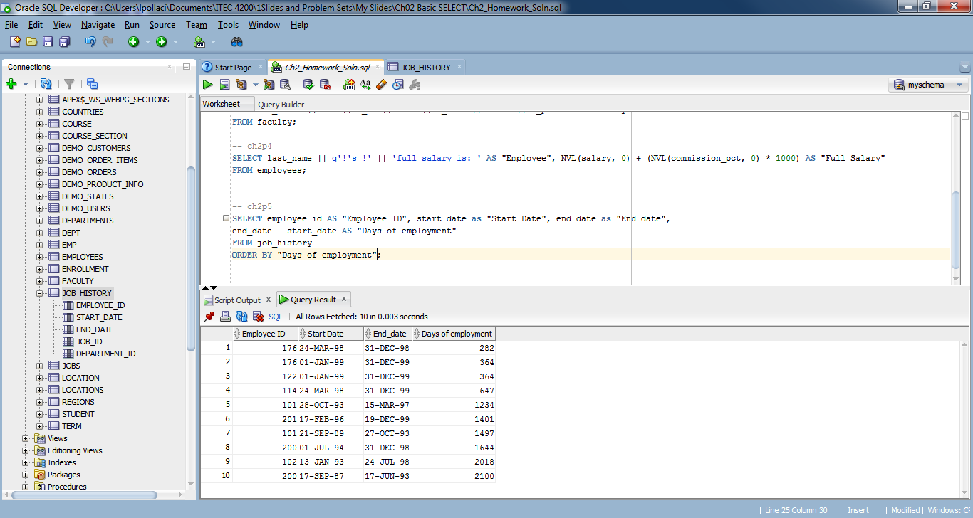

1. Using the Animal Shelter schema, create a new problem using the features introduced in this chapter.